

Lab - Explore DNS Traffic

Nombre: Luis Enrique Pérez Señalin

# Objectives

## Part 1: Capture DNS Traffic

**Part 2: Explore DNS Query Traffic Part 3: Explore DNS Response Traffic**

# Background / Scenario

Wireshark is an open source packet capture and analysis tool. Wireshark gives a detailed breakdown of the network protocol stack. Wireshark allows you to filter traffic for network troubleshooting, investigate security issues, and analyze network protocols. Because Wireshark allows you to view the packet details, it can be used as a reconnaissance tool for an attacker.

In this lab, you will install Wireshark on a Windows system and use Wireshark to filter for DNS packets and view the details of both DNS query and response packets.

# Required Resources

* 1 Windows PC with internet access and Wireshark installed

# Instructions

**Part 1: Capture DNS traffic.**

1. 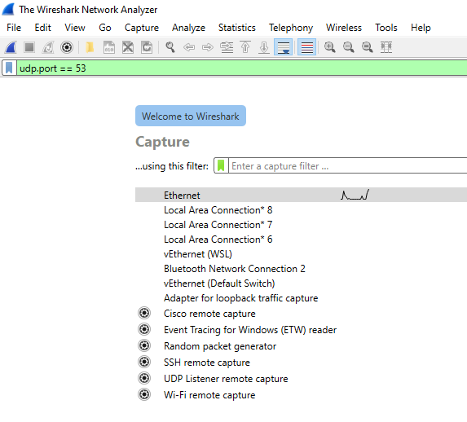Open **Wireshark** and start a Wireshark capture by double clicking a network interface with traffic.
2. At the Command Prompt, enter **ipconfig /flushdns** clear the DNS cache.

C:\Users\Student> **ipconfig /flushdns**

Windows IP Configuration

Successfully flushed the DNS Resolver Cache.

1. Enter **nslookup** at the prompt to enter the nslookup interactive mode.
2. Enter the domain name of a website. The domain name [**www.cisco.com**](http://www.cisco.com/) is used in this example. Enter

[**www.cisco.com**](http://www.cisco.com/) at the > prompt.

C:\Users\Student> **nslookup** Default Server: UnKnown Address: 68.105.28.16

> [**www.cisco.com**](http://www.cisco.com/)Server: UnKnown Address: 68.105.28.16

Non-authoritative answer:

Name: e2867.dsca.akamaiedge.net Addresses: 2001:578:28:68d::b33

2001:578:28:685::b33

96.7.79.147

Aliases: [www.cisco.com](http://www.cisco.com/)

[www.cisco.com.akadns.net](http://www.cisco.com.akadns.net/) wwwds.cisco.com.edgekey.net wwwds.cisco.com.edgekey.net.globalredir.akadns.net

1. Enter **exit** when finished to exit the nslookup interactive mode. Close the command prompt.
2. 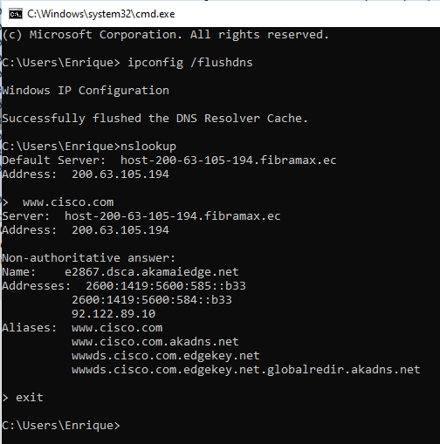Click **Stop capturing packets** to stop the Wireshark capture.

# Part 2: Explore DNS Query Traffic

1. Observe the traffic captured in the Wireshark Packet List pane. Enter **udp.port == 53** in the filter box and click the arrow (or press enter) to display only DNS packets.
2. Select the DNS packet labeled **Standard query 0x0002 A** [**www.cisco.com**.](http://www.cisco.com/)

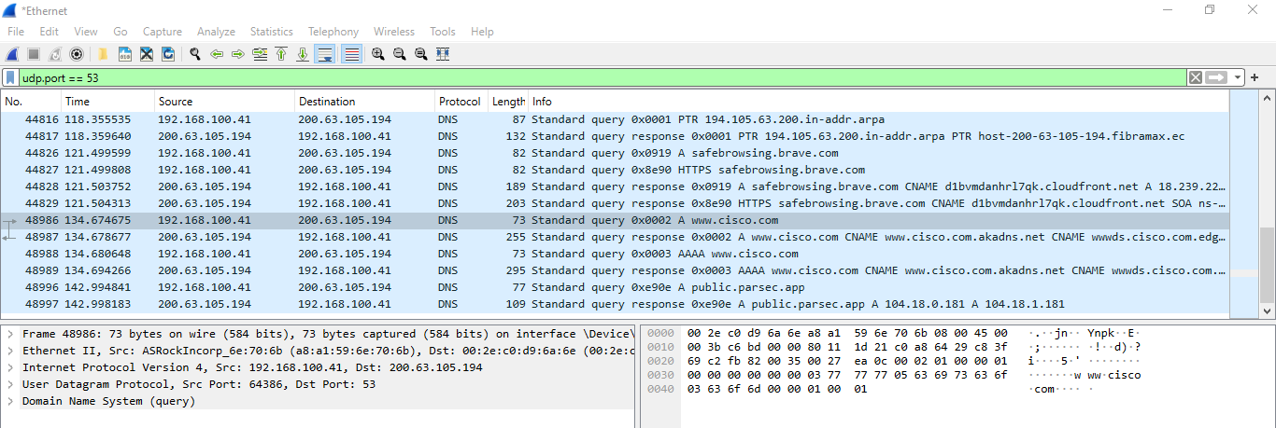In the Packet Details pane, notice this packet has Ethernet II, Internet Protocol Version 4, User Datagram Protocol and Domain Name System (query).

1. 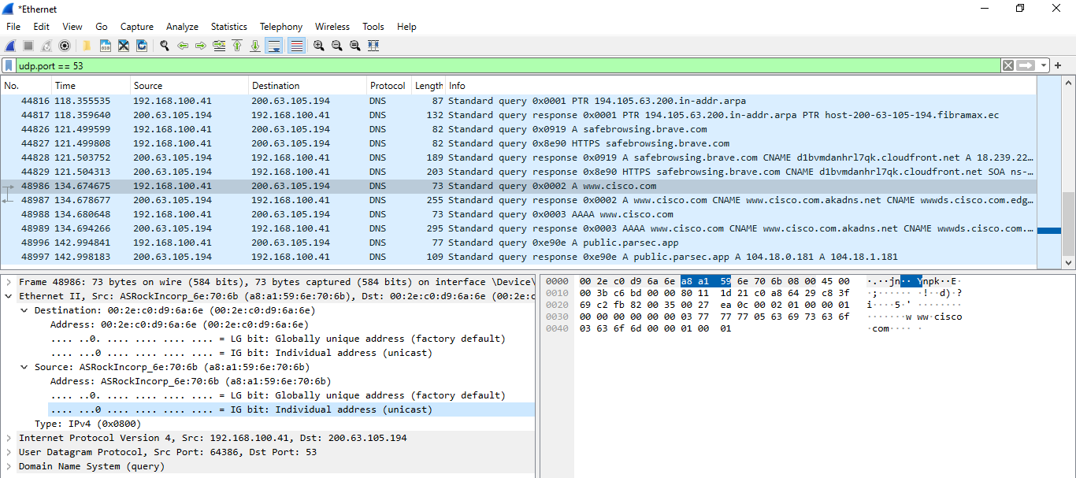Expand **Ethernet II** to view the details. Observe the source and destination fields.

What are the source and destination MAC addresses? Which network interfaces are these MAC addresses associated with?

**R:** Destination MAC addresses: 00:2e:c0:d9:6a:6e Source MAC addresses: a8:a1:59:6e:70:6b.

1. 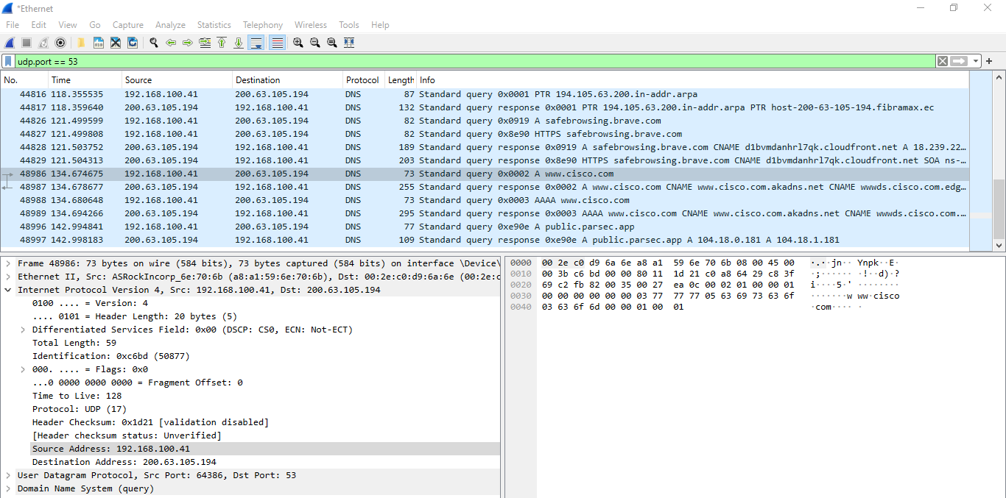Expand **Internet Protocol Version 4**. Observe the source and destination IPv4 addresses.

What are the source and destination IP addresses? Which network interfaces are these IP addresses associated with?

**R:** Source IP addresses: 192.168.100.41, Destination IP addresses: 200.63.105.194

* 1. Expand the **User Datagram Protocol**. Observe the source and destination ports.

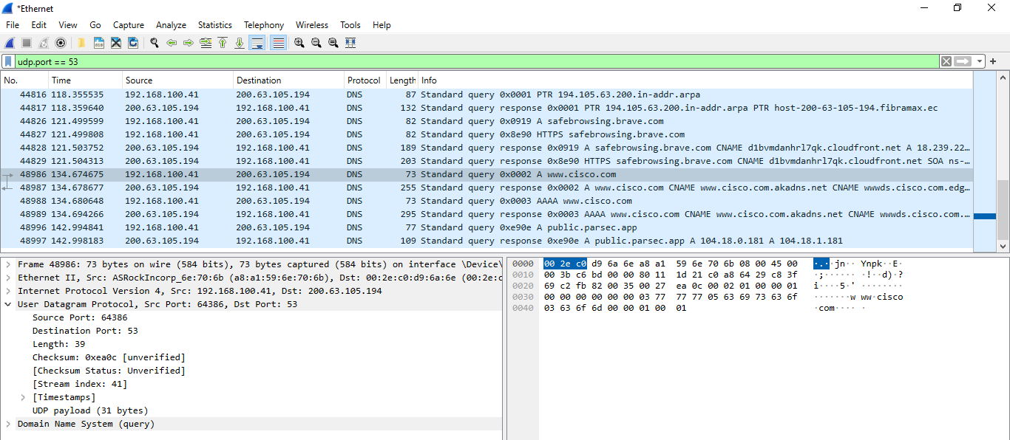

What are the source and destination ports? What is the default DNS port number?

**R:** Source port: 64386, Destination port: 53, Default DNS port number: 5

* 1. Open a Command Prompt and enter **arp –a** and **ipconfig /all** to record the MAC and IP addresses of the PC.

C:\Users\Student> **arp -a**

|  |  |  |
| --- | --- | --- |
| Interface: 192.168.1.10  Internet Address | --- 0x4  Physical Address | Type |
| 192.168.1.1 | cc-40-d0-18-a6-81 | dynamic |
| 192.168.1.122 | b0-a7-37-46-70-bb | dynamic |
| 192.168.1.255 | ff-ff-ff-ff-ff-ff | static |
| 224.0.0.22 | 01-00-5e-00-00-16 | static |
| 224.0.0.252 | 01-00-5e-00-00-fc | static |
| 239.255.255.250 | 01-00-5e-7f-ff-fa | static |
| 255.255.255.255 | ff-ff-ff-ff-ff-ff | static |

C:\Users\Studuent> **ipconfig /all**

Windows IP Configuration

Host Name . . . . . . . . . . . . : DESKTOP

Primary Dns Suffix . . . . . . . :

Node Type . . . . . . . . . . . . : Hybrid IP Routing Enabled. . . . . . . . : No

WINS Proxy Enabled. . . . . . . . : No Ethernet adapter Ethernet:

Connection-specific DNS Suffix . :

Description . . . . . . . . . . . : Intel(R) PRO/1000 MT Desktop Adapter Physical Address. . . . . . . . . : 08-00-27-80-91-DB

DHCP Enabled. . . . . . . . . . . : Yes Autoconfiguration Enabled . . . . : Yes

Link-local IPv6 Address . . . . . : fe80::d829:6d18:e229:a705%4(Preferred) IPv4 Address. . . . . . . . . . . : 192.168.1.10(Preferred)

Subnet Mask . . . . . . . . . . . : 255.255.255.0

Lease Obtained. . . . . . . . . . : Tuesday, August 20, 2019 5:39:51 PM Lease Expires . . . . . . . . . . : Wednesday, August 21, 2019 5:39:50 PM Default Gateway . . . . . . . . . : 192.168.1.1

DHCP Server . . . . . . . . . . . : 192.168.1.1

DHCPv6 IAID . . . . . . . . . . . : 50855975

DHCPv6 Client DUID. . . . . . . . : 00-01-00-01-24-21-BA-64-08-00-27-80-91-DB DNS Servers . . . . . . . . . . . : 68.105.28.16

68.105.29.16

NetBIOS over Tcpip. . . . . . . . : Enabled

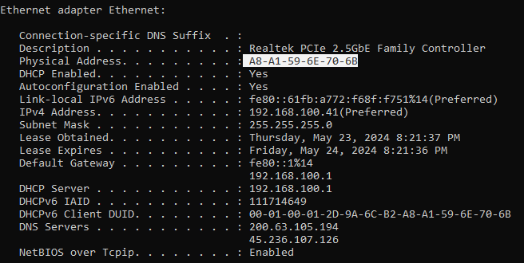Output:

Compare the MAC and IP addresses in the Wireshark results to the results from the **ipconfig /all**

results. What is your observation?

**R:** The Physic Address is the same that the source MAC addresses, and the IPv4 Address is the same as the source IP address.

* 1. Expand **Domain Name System (query**) in the Packet Details pane. Then expand the **Flags** and

## Queries.

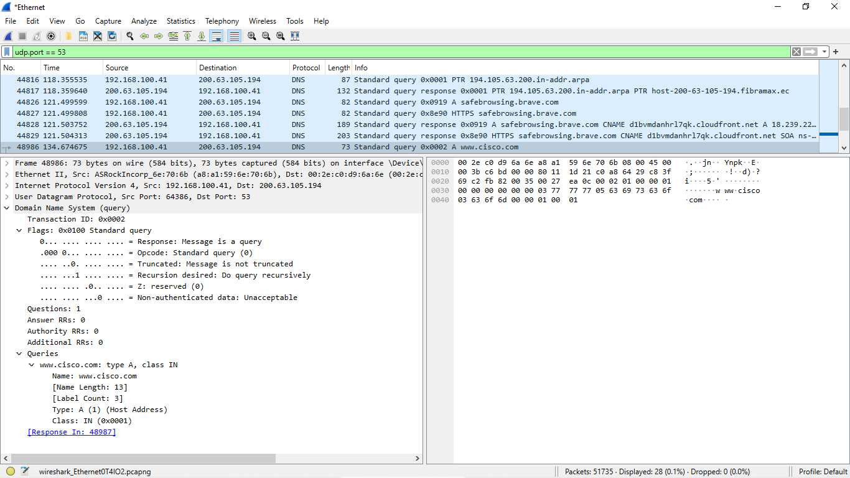Observe the results. The flag is set to do the query recursively to query for the IP address to [www.cisco.com.](http://www.cisco.com/)

# Part 3: Explore DNS Response Traffic

1. 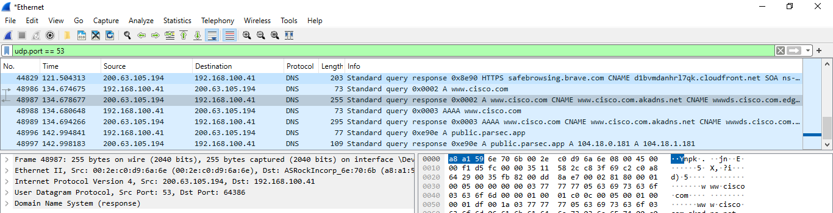Select the corresponding response DNS packet labeled **Standard query response 0x0002 A** [**www.cisco.com**.](http://www.cisco.com/)

What are the source and destination MAC and IP addresses and port numbers? How do they compare to the addresses in the DNS query packets?

**R:** Destination MAC addresses: a8:a1:59:6e:70:6b Source MAC addresses: 00:2e:c0:d9:6a:6e. Source IP addresses: 200.63.105.194, Destination IP addresses:192.168.100.41. The difference between the query and the response DNS, is that the source and the destination was swapped because our computer recipe the response packet and not send the query packet.

1. 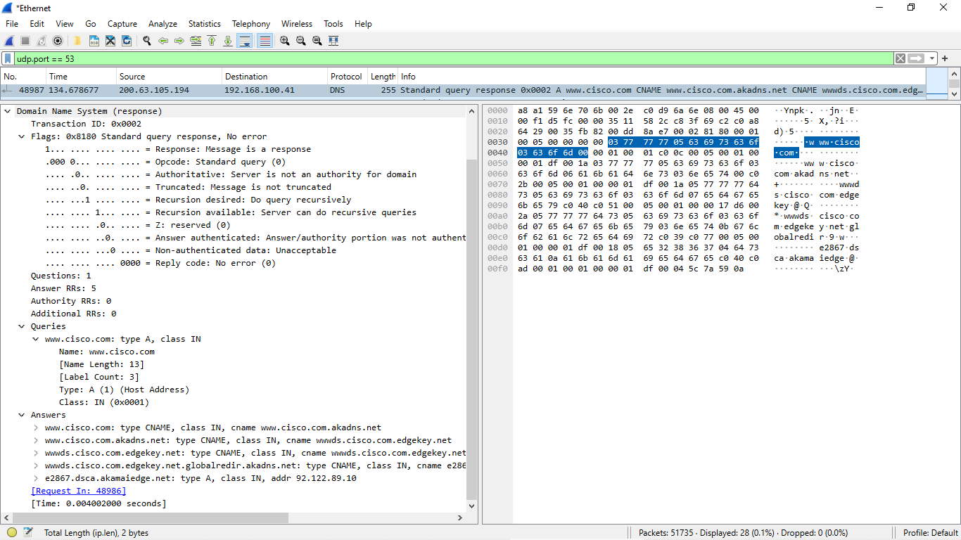Expand **Domain Name System (response)**. Then expand the **Flags**, **Queries**, and **Answers**. Observe the results.

Can the DNS server do recursive queries?

**R**: Yes, a response can contain multiple response, in this case 5 response.

1. Observe the CNAME and A records in the answers details. How do the results compare to nslookup results?

**R:** I can´t understand the question.

# Reflection Question

1. From the Wireshark results, what else can you learn about the network when you remove the filter?

I can see the DNS request on the network, like what urls are querying on my network, and what is the source IP, and I can see what is my DNS server

1. How can an attacker use Wireshark to compromise your network security?

A attacker can do a dns spoofing to redirection all the dns request to a fake portal pages and get the credentials of the users or invalid the network redirection all the urls to a failed page.

**Note:** All the images was extracted of my personal computer, including wireshark screenshots and prompt screenshots. The prompt screenshot included the username: Enrique